Since our e- book doesn’t have any cover, your task is to design one!! Here are some ideas!!

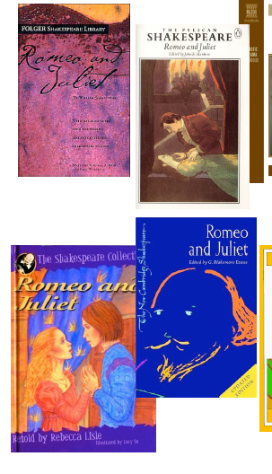

Here are some book covers of Shakespeare’s Romeo and Juliet adaptations.