NAME……………………………………............. DATE………… CLASS ………....

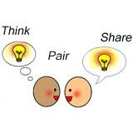

THINK-PAIR-SHARE WORKSHEET

MY IDEA

1.……………………………………………………………………………………………………………………………………………………………….

2.……………………………………………………………………………………………………………………………………………………………….

3.………………………………………………………………………………………………………………………………………………………………..

MY PARTNER’S IDEA

1…………………………………………………………………………………………………………………………………………………………….

2.……………………………………………………………………………………………………………………………………………………………….

3.………………………………………………………………………………………………………………………………………………………………..

WHAT WE WILL SHARE

1…………………………………………………………………………………………………………………………………………………………….

2.……………………………………………………………………………………………………………………………………………………………….

3.………………………………………………………………………………………………………………………………………………………………..