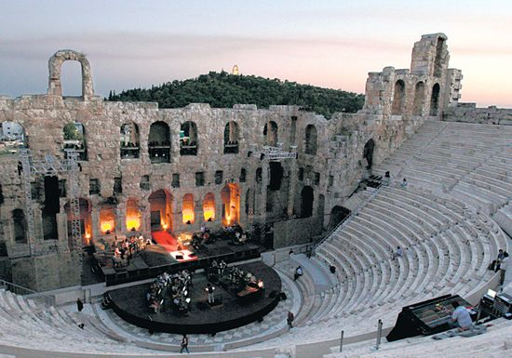

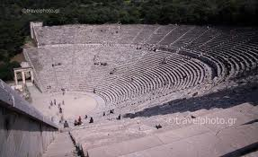 Επίδαυρος

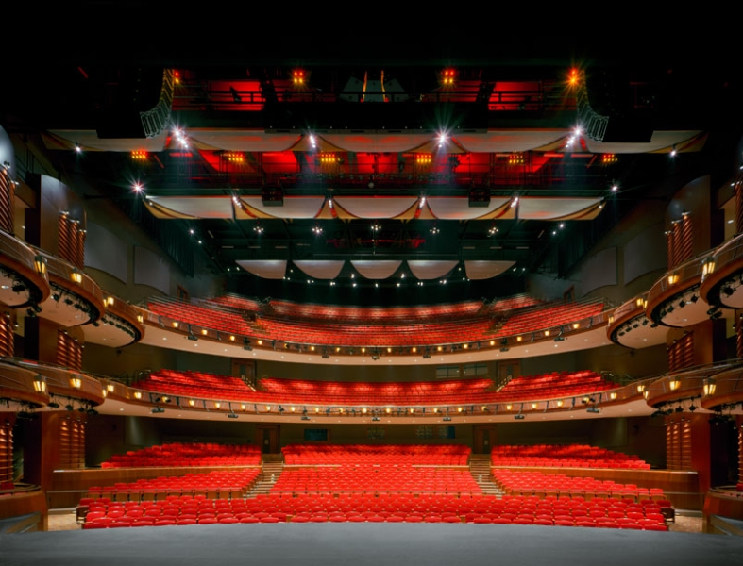
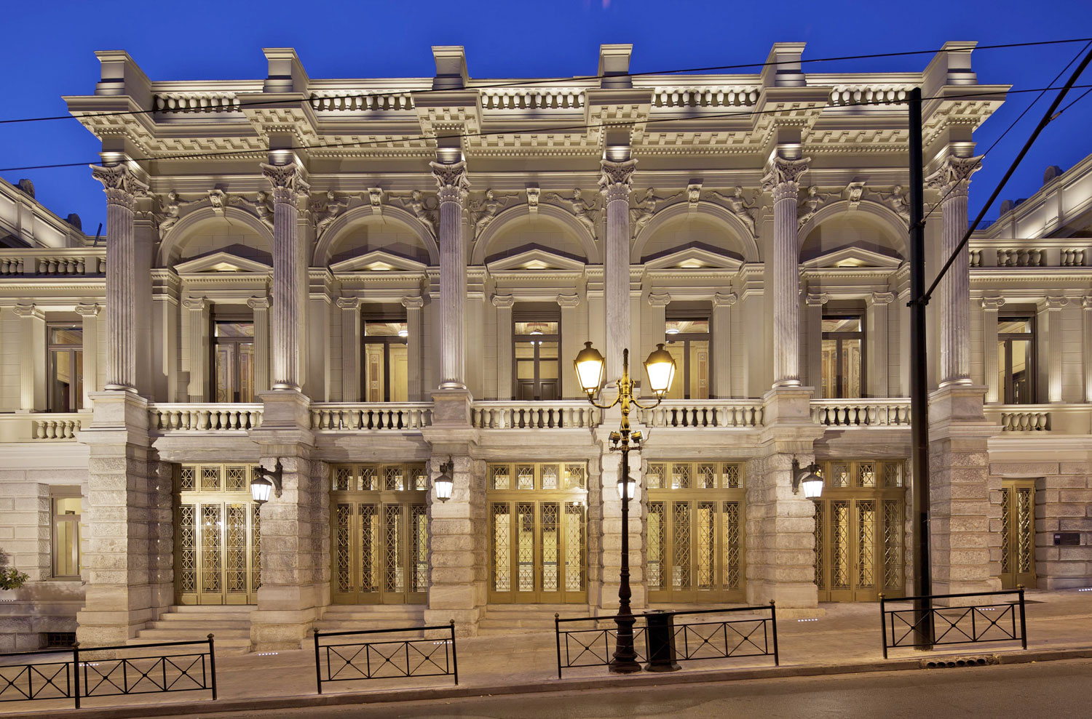 Εθνικό θέατρο
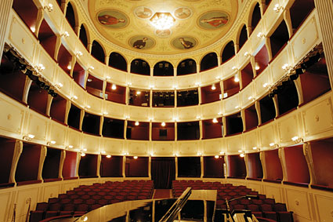

Here you found some pictures of ancient and contemporary theatres from all over the world. These are taken for an article in your school newspaper concerning different theatre styles. Your task is to be the reporter and write a small paragraph about the newspaper identifying any similarities or differences between contemporary theatres and the Globe.
__________________________________________________________________________________________________________________________________________________________________________________________________________________________________________________________________________________________________________________________________________________________________________________________________________________________________________________________________________________________________________________________________________________________________________________________________________________________________________________________________________________________________

